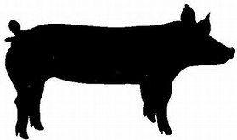

You may buy a whole or half hog. Price is $450 for a whole hog and $250 for a half. Processing fee is not included. Processing can range from $200-$300 for a whole hog. We strive to harvest our hogs at 280 lbs, which will yield approximately 140 lbs. of pork in your freezer.

Payment is made in two (2) equal installments while we are caring for the animal.
Name:_____________________________Date:_________
Phone:_____________________________
E-mail address:____________________________________
Request: whole half
Signature:_______________________________________
Return this form with your deposit to:
Tuff Girl Livestock Productions LLC
7208 Cincinnati Brookville Rd.
Okeana, OH 45053
QUESTIONS? Call us at 513-305-9445

