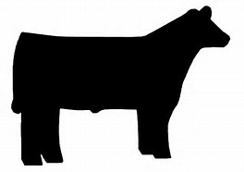

You may buy a 1/4, 1/2 or whole beef. Price is as follows:
1/4- $2.60/pound (live weight)
1/2- $2.50/pound (live weight)
Whole- $2.40/pound (live weight)
Processing fee is not included. Processing can range from $400-$600 for a whole beef. We strive to harvest our cows at 1,200 lbs., which will yield approximately 550 lbs. of beef in your freezer.
Payment is made in three (3) installments (deposit of $960) while we are caring for the animal.
Name:_____________________________Date:_________
Phone:_____________________________
E-mail address:____________________________________
Request: whole half quarter
Signature:_______________________________________
Return this form with your deposit to:
Tuff Girl Livestock Productions LLC
7208 Cincinnati Brookville Rd.
Okeana, OH 45053
QUESTIONS? Call us at 513-305-9445

